Question 5 [6 Points]
Create a shell script sync.sh to compare two directories dirA and dirB.Your script should:
• List files present only in dirA • List files present only in dirB
• For files with the same name in both directories, check whether their contents matchDo NOT copy or modify files.Use diff, cmp, or checksum techniques.
----
Scirpt:
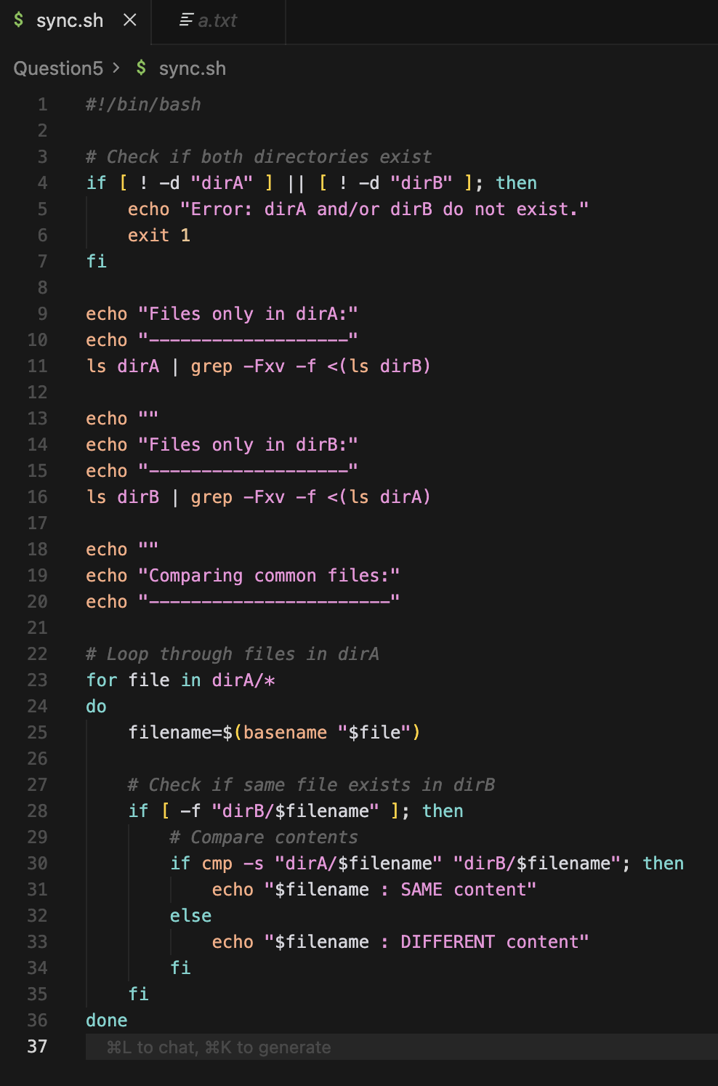
Explanation:
if [ ! -d "dirA" ] || [ ! -d "dirB" ]; then :
This check if the created directory exist in the folder.
for file in dirA/*
for : loop keyword
do : loop body starts
if cmp -s "dirA/$filename" "dirB/$filename"; then
cmp : comprae two files byte by byte
-s : silent mode
done : ends the loop
The script compares directory contents using filename comparison and verifies file integrity using the cmp cmd without modifying any files
Output:

